Assignment 1:
to become familiar with the networking assesories and facilities in the department of comuter science.
- Find out what networking devices that are installed in department.
- Describe the network type and topology in departments.
- Finding ip and mac addresses
- Workgroup and domain configuration
- Use of utilities arp,ipconfig/ifconfig,tracert,nslookup

Answer:

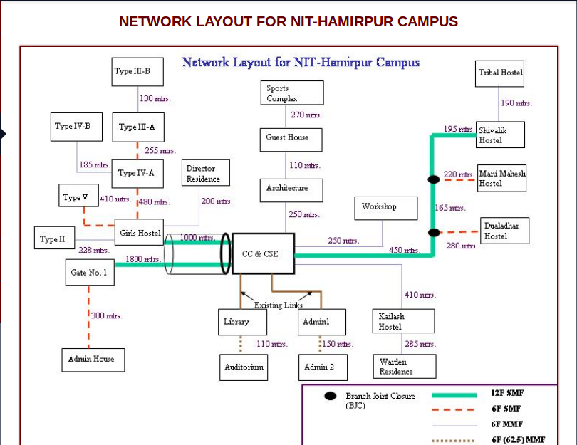

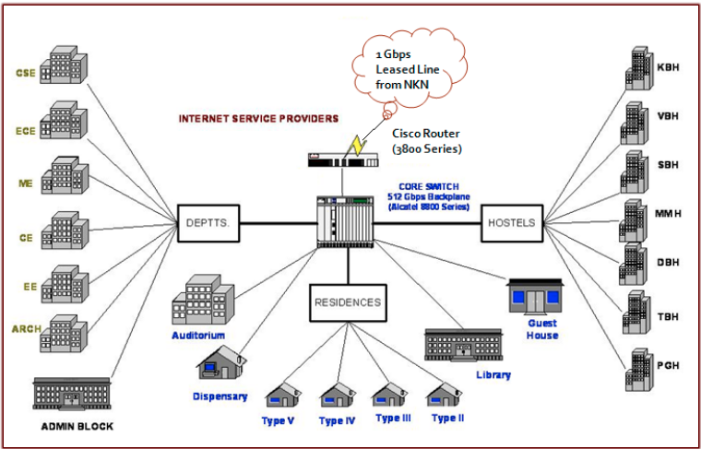

Type of network in the college is LAN.
Network topology used in the network is a hybrid topology consisting of some star topologies.

Workgroup:
Workgroup is Microsoft's term for peer-to-peer local area network. Computers running Microsoft operating systems in the same workgroup may share files, printers, or Internet connection. Workgroup contrasts with a domain, in which computers rely on centralized authentication.

Domain:
On a local area network (LAN), a domain is a subnetwork made up of a group of clients and servers under the control of one central security database. Within a domain, users authenticate once to a centralized server known as a domain controller, rather than repeatedly authenticating to individual servers and services.

ARP:
Short for Address Resolution Protocol, a network layer protocol used to convert an IP address into a physical address (called a DLC address), such as an Ethernet address. A host wishing to obtain a physical address broadcastsan ARP request onto the TCP/IP network.
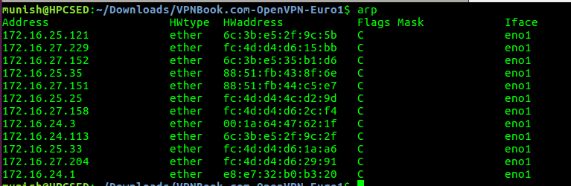
Ifconfig:
ifconfig is a system administration utility in Unix-like operating systems for network interface configuration.
The utility is a command line interface tool and is also used in the system startup scripts of many operating systems. It has features for configuring, controlling, and querying TCP/IP network interface parameters.
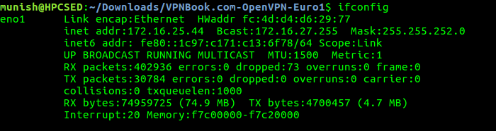

Tracert:
The tracert command is a Command Prompt command that's used to show several details about the path that a packet takes from the computer or device you're on to whatever destination you specify.

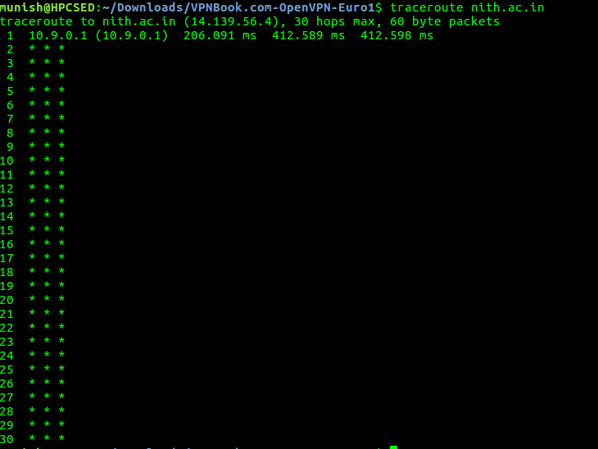

Nslookup:
nslookup is a network administration command-line tool available for many computer operating systems for querying the Domain Name System (DNS) to obtain domain name or IP address mapping or for any other specific DNS record.

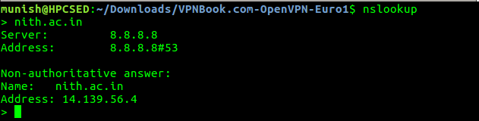

Assignment2:
Configure the mobile device with laptop,mobile phone in the infrastructure based and infrastructure less kind of structure

